Southern Africa by 1860’s
Brought to the British colony of Natal in1860 as indentured labourers, coolies, on five-year contracts, Indians came to work mainly on sugar plantations where they lived under very harsh and cruel conditions. After five years, they were given the options of renewing their contracts, returning to India or becoming independent workers. To induce the coolies into second terms, the colonial government of Natal promised grants of land on expiry of contracts. But the colony did not honour this agreement and only about fifty people received plots. Nevertheless, many opted for freedom and became small holders, market gardeners, fishermen, domestic servants, waiters or coal miners. Some left the colony. By the 1870's, free Indians were exploring opportunities in the Cape Colony, the Orange Free State and the South African Republic (Transvaal). Those who sought to make their fortunes in the diamond and gold fields were not allowed digging rights and became traders, hawkers and workers.
The first group of Indians arrived in the British colony of Natal in 1860. About 150 indentured labourers arrived at Port Natal on board the ship Truro. When the sugar industry was established in Natal the local Zulu labourers were recruited to work on the sugar plantations. However, the Natal colonial authorities were not initially aware that Zulu males regarded agricultural work as a female activity. Traditionally, the Zulu males were involved in grazing cattle and defending the tribe against foreign attack. The high labour turnover forced the colonial authorities to seek Indian labour that was already successfully employed in other British colonies. The indentured labourers were given a monthly stipend of two British pounds. They were also given provisions and their health needs were catered for. Their earnings as indentured labourers were considerably higher than they could earn in India. Therefore, future shipments of indentured labourers were highly successful. At the end of the initial three year contract the indentured labourers were given a free passage back to India or given agricultural land equivalent to the value of a passage back to India. Owning their own land was an unlikely event in their homeland of India and it is understandable that the majority preferred to remain in South Africa.
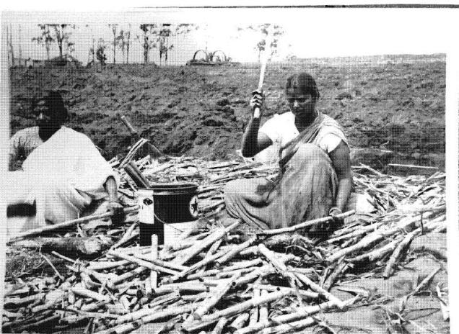Indentured Labourers working at a sugar estate in South Africa. Image source
The working conditions of the indentured labourers were harsh. The plantation owners demanded long hours of work in the oppressive humid climate of Natal. Harsh punishment was meted out on labourers who could not keep up with the heavy workload. Their problems were compounded by the fact that they were living in a foreign land with a foreign culture and they also had to contend with many foreign languages. Not everyone could cope with the severe demands. But those who did became land-owning free Indians, considered to be wealthy by the standards of their former homeland. In 1869 a new wave of immigration occurred, of traders from the West Coast, mainly Gujerat. They were called "passenger" Indians as distinct from indentured Indians. The new immigrants, mainly Moslems, were attracted by the rich potentialities for trade that Natal offered. The Gujerati speaking traders were laterjoined by some Urdu speaking Moslems from the United Province and a few Marathi speaking Kokince Moslems.
Diamond Mining in Kimberley from 1867 onwards
Diamonds were formed billions of years ago and are extremely rare because so few are able to survive the difficult journey from the pits of the earth to reach the earth’s surface. From the diamonds that are being mined today, only about 50 percent are thought to be high enough quality to be sold on the diamond market. Many skilled experts will handle a diamond before it makes it to the one that is coveting such a precious stone. The story of diamonds in South Africa begins between December 1866 and February 1867 when 15-year-old Erasmus Jacobs found a transparent rock on his father’s farm, on the south bank of the Orange River. Suddenly, both the Boers and the British were interested in the sovereignty over the area. The area soon attracted a large number of white fortune hunters. Over the next few years, South Africa yielded more diamonds than India had in over 2,000 years.
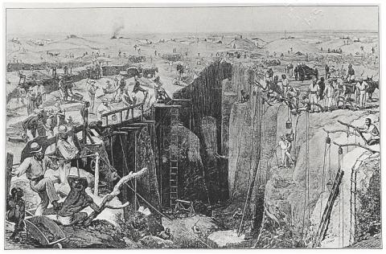Diamond Mining in South Africa Image source
In the 1870′s and 1880′s Kimberley, encompassing the mines that produced 95% of the world’s diamonds, was home to great wealth and fierce rivalries, most notably that between Cecil John Rhodes and Barney Barnato.In 1848 the British annexed the entire area between the Orange and Vaal Rivers, which included the Griqualand area, and called it the Orange River Sovereignty with a Magistrate at Bloemfontein who flew the Union Jack. Due to the high costs and low returns the British were to withdraw from the area thanks to the Bloemfontein Convention. It did not help the British that they were about to embark on the Crimean War, so they were looking to consolidate imperial adventures for the time being. In 1854 the Orange Free State was established and the Transvaal would slowly form by 1860. This also meant that Griqualand West was technically independent but it would have to fight off incursions from Boers or any other interested groups. Official British interest in Griqualand was purely opportunistic. In the early 1870s rich diamond mines were discovered. As Griqualand West bordered Transvaal and the Cape Colony, both colonies would claim an interest. The Boers and the British were antagonistic and hostile to each other; each colony did not wish the other to take control of such a rich resource.
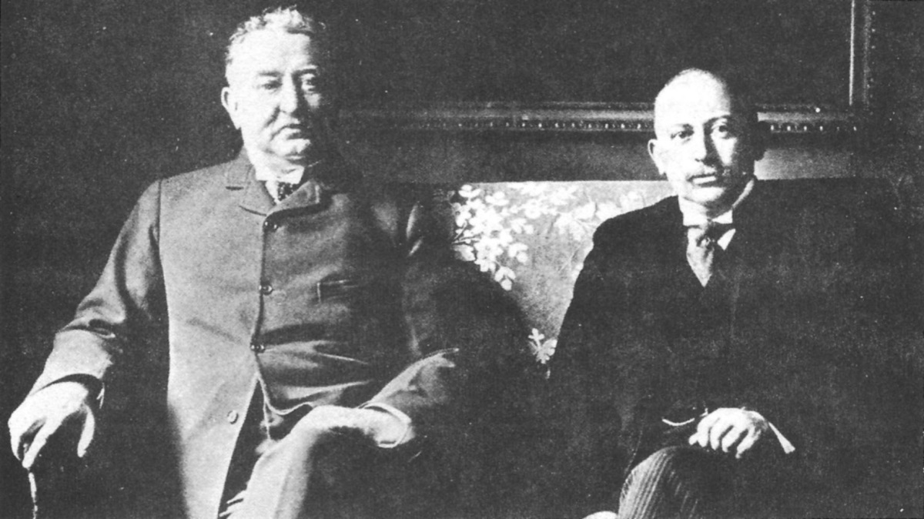Cecil Rhodes (left) and Alfred Beit Image source
Rhodes, sensing he had ventured into an untapped market, bought up diamond fields, including one owned by two brothers named "de Beer." In 1880, he bought the claims of fellow entrepreneur and rival Barney Barnato to create the De Beers Mining Company. The tendency in diamond mining is to combine with smaller groups to form larger ones. Individuals needing common infrastructure form diggers committees and small claim holders wanting more land merge into large claimholders. Thus, it only took a few years for De Beers to become the owner of virtually all South African diamond Mines.

1. Explain the following terms as they are used in the extract:
- indentured labourers
- stipend
- passenger Indians
- contract
2. a) What options were open to the Indians after 5 years. Name the three. (3)
b) What motivation was given to the Indians to encourage them to renew their contracts?
c) Were the promises honoured? Why?
d) Eventually, what became of those that were left in the cold? (4)
3. Why did the Natal Colonial Authorities opt for Indian labour instead of the Zulu males who were locally available? (3)
4. Compare the life of indentured labourers in their new found home in Natal and back at home in India. Explain in what ways it was better. (4)
5. Describe the working conditions of the indentured labourers. What other challenges did they face in Natal? (4)
6. Give a brief description of how the story of diamonds began in South Africa. How did Kimberly become the hub of diamond mining. Make reference to the competition between the British and the Boers. (6)
7. Trace the steps that Cecil John Rhodes followed to become a mining magnet with his famous De Beers Mining Company. (6)

